PLC LAB 10

Data Manipulation Instructions

1. Write a program to read the voltage from the Analog Input pot and output the value to the analog output screen. You will need to go into the I/O configuration and configure the Input and output Analog Configuration and Output Limits.

|  |  |  |
| --- | --- | --- |
|  |  |  |
|  |  |  |

. 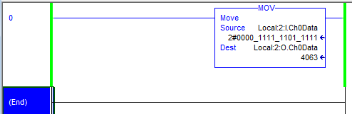

1. Using Local:2:I ch2 Data connect an input 4 to 20 mA current **(must use a resistor to control the current)** circuit using the Elvis 115 Volt power supply. Output the current to Local:2:O ch1 and monitor the circuit current with a DMM.
2. Using Local:2:I ch2 Data connect an input 0 to 10 volts **(must use a resistor to control the voltage)** circuit using the Elvis 15 Volt power supply. Output the current to Local:2:O ch1 and monitor the circuit current with a DMM.
3. Using the circuits from problem 2, create a program that assumes the current is monitoring a tank. If the current is greater than 15 mA a red LED light comes on. Monitor the tank on PanelView use the graphs functions under objects.

